Industry 4.0 in Chemical Manufacturing Industry



Highlights:

* What can Industry 4.0 do for chemicals?
* How to enable Industry 4.0 technologies to help in chemical industry
* From where can Chemical companies start their journey ?

The chemicals industry contributes to almost every manufactured product. The global chemical industry is truly the backbone of many end-market industries such as agriculture , automotive and many other . Thus it is obvious that any change in the chemical industry is highly likely to have a considerable impact on other industries.

The fourth Industrial revolution is more likely to drive such changes . Industry 4.0 blends a number of digital and physical advanced technologies to form a greater connection that will have the potential to transform the chemicals industry .

What can Industry 4.0 do for chemicals?

Organizations focussed on business operations can use Industry 4.0 technology to enhance productivity and reduce risks. while those focussed on growth can use it to increase income or generate a new source for the same.

KEY OBJECTIVE TRANSFORMATIONAL PLAYS

|  |  |  |
| --- | --- | --- |
| * Enhanced productivity * Minimized Risks | Smart Manufacturing | 1. Predictive asset management: Maximize utilization of assets and minimize unplanned downtime 2. Managing and controlling of the process: Minimize production variability and enhances quality 3. Managing energy: Reduce energy costs and assess alternative energy sources 4. Managing safety: Monitor assets, processes, people, and products on a continuous and real-time basis 5. Production simulation: Improve operator training, manufacturing planning, and timely plant commissioning |
| Supply chain planning | 1. Managing safety 2. Forecasting demand: Demand forecasting: Adjust production schedules in line with changing customer needs |
| * Increasing revenue * Getting new sources for revenue | Development and research | 1)Additive manufacturing  2)Selection of materials through advanced analytics  3)4D printing for development of advanced materials. |
| Smart Products and Services | 1)Smart product development  2)Offering data services  3)Building new revenue  models |

Enabling Industry 4.0 technologies to help in chemical industry

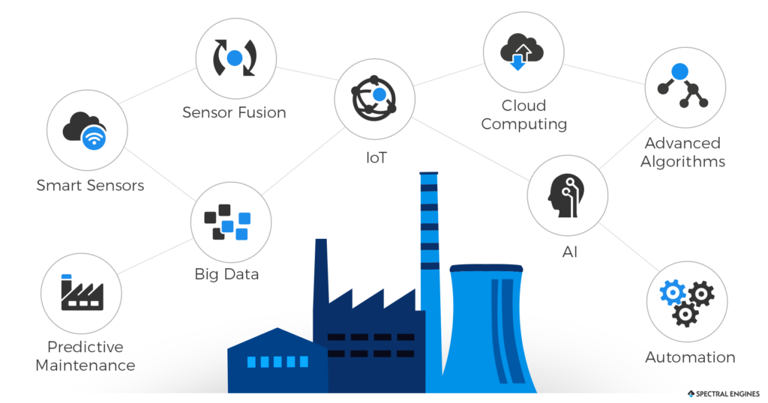

Industry 4.0 facilitates the transformation of the chemical industry by streamlining operations and supporting strategic growth . The technologies of Industry 4.0 can be integrated with various processes to digitally enhance their business operations.

There are certain factors that enable a smoother Industry 4.0 journey for the chemical industry.

Let us have a look at them one by one :

* **Incorporating all the essential technologies:**

The most important part in enabling Industry 4.0 is to integrate all the technologies that facilitate the smart transformation

* **Data Management:**

Chemical companies often have their data scattered over data systems which makes the collection , storage and processing of the data a hectic and inefficient task . Thus these data must be combined and stored at a central hub so that it is easy to get a holistic view of the organization.

* **Advanced Analytics:**

After aggravation of data , advanced analytics comes into play to makes sense of the information to drive action in the physical realm. This data can be used to gain insights on various domains , their shortcomings and guide informed decision making.

* **Digital interface** :

The insights generated using advanced analytics are now passed on to the business users so that they can customize the applications based on the same.

* **Business Imperatives:**

After prioritizing all the factors listed above , the chemical companies can use the data to determine what action they want to undertake , where they want to go from there , so on and so forth.

Where can Chemical companies start their journey from?

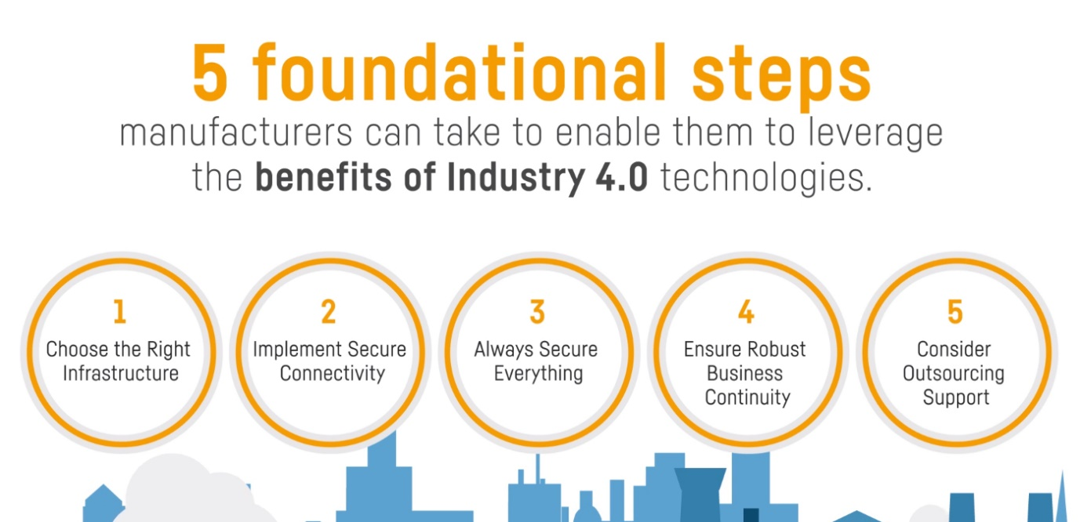

* Strong Foundation areas: A good idea would be to start from the area of strong base and then gradually move onto newer technologies and more complex applications.
* Enabling a cross-functional Industry 4.0 team
* Collaborations : Chemical companies need to partner with technology vendors, analytics providers ,etc and make use of the collected data to gain insights on developing smart chemical product and building new revenue models.
* Safety and Security : There should be an organized and effective policy to keep track of cyber risks and chemical companies should make use of technology that can help them manage the risks posed to their company.

Conclusion

Industry 4.0 is having a profound impact in every domain , leaving no sector untouched and it is more than likely to impact the way chemical companies function and flourish their business. The deciding factor that which all industries will perform impressively is how well they adapt to the needs of the hour and prepare themselves to adopt a revolution that is bound to change them for the better , helping them achieve heights hitherto undreamt of.